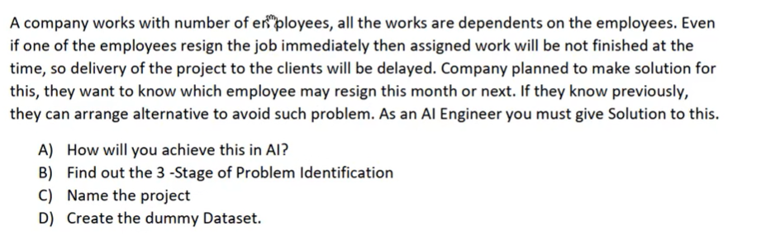

**How will you achieve this in AI?**

Requirement: Predict whether an employee is likely to resign or not

Do the prediction using employee job satisfaction score and provide output as 0->Stay, 1->Resign

**Find out the 3-Stage of Problem Identification?**

ML(NLP can be used as well) 🡪 Supervised -> Calssification

**Name the project?** Resignation predictor

**Dummy Dataset:**

|  |  |  |  |
| --- | --- | --- | --- |
| Emp. No | Years at Company | Job Satisfaction | Resign |
| 001 | 5 | 2 | Resign |
| 002 | 7 | 5 | Stay |
| 003 | 2 | 4 | Stay |
| 004 | 10 | 1 | Resign |
|  |  |  |  |